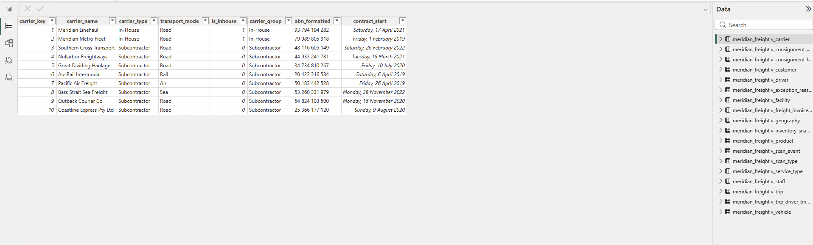

6B.4 Sort-by-column configuration

For DateTable
Sorting text column like Month, Quarter, FinQuater sorting by next column like MonthNumber, QuarterNumber, FinQuaterNumber.
Text column requires numeric column to sort.
QuarterNumber and FinQuarterNumber themselves are just helper columns — they exist purely so the other columns have something numeric to sort by. You likely won't even display them in your reports/visuals directly; they just sit in the background doing the sorting work.

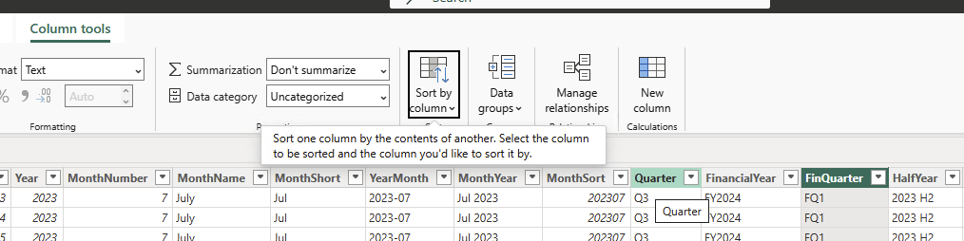

6B.5 Minimal Power Query steps
V_scan_event

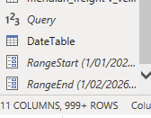

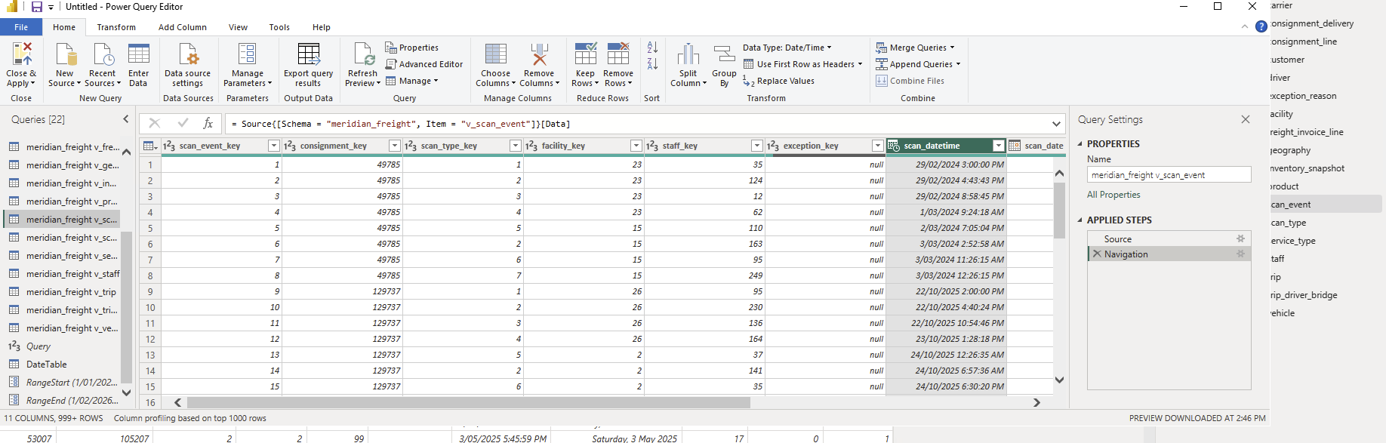

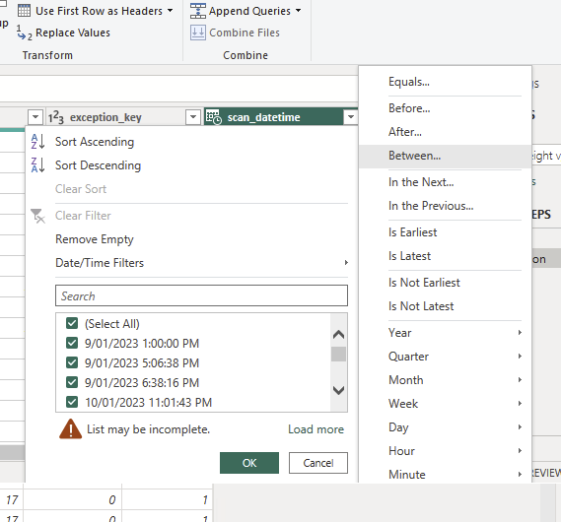

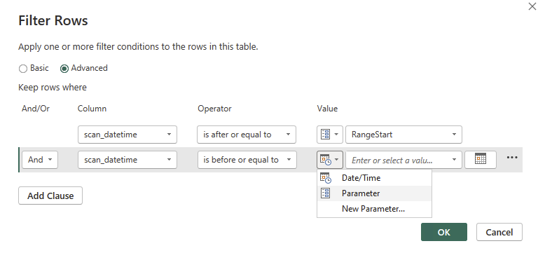

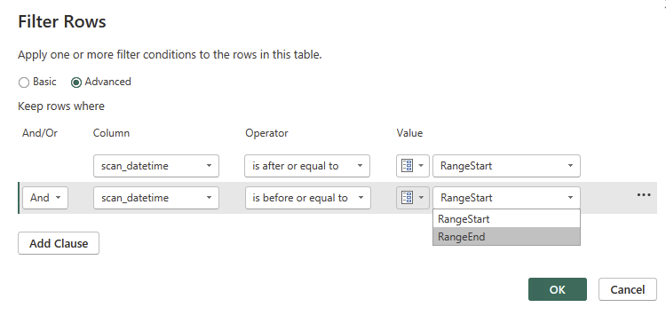

Verify Folding Survived

Method 1: Right-click the step → "View Native Query"
- In Power Query Editor, click on your scan_event query
- In the Applied Steps pane (right side), right-click on the step where you applied the scan_datetime filter (e.g., "Filtered Rows")
- Look for View Native Query
- If it's clickable (not greyed out) → folding survived at that step. Clicking it shows you the actual SQL Power Query would send to MySQL, including your WHERE scan_datetime >= ... AND scan_datetime < ... clause.
- If it's greyed out → folding broke at or before that step. Something in your query (a prior transformation, a data type conversion, a merge, a custom column, etc.) prevented MySQL from being able to execute that logic natively, so Power Query pulled data into memory first.

- 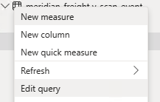

- 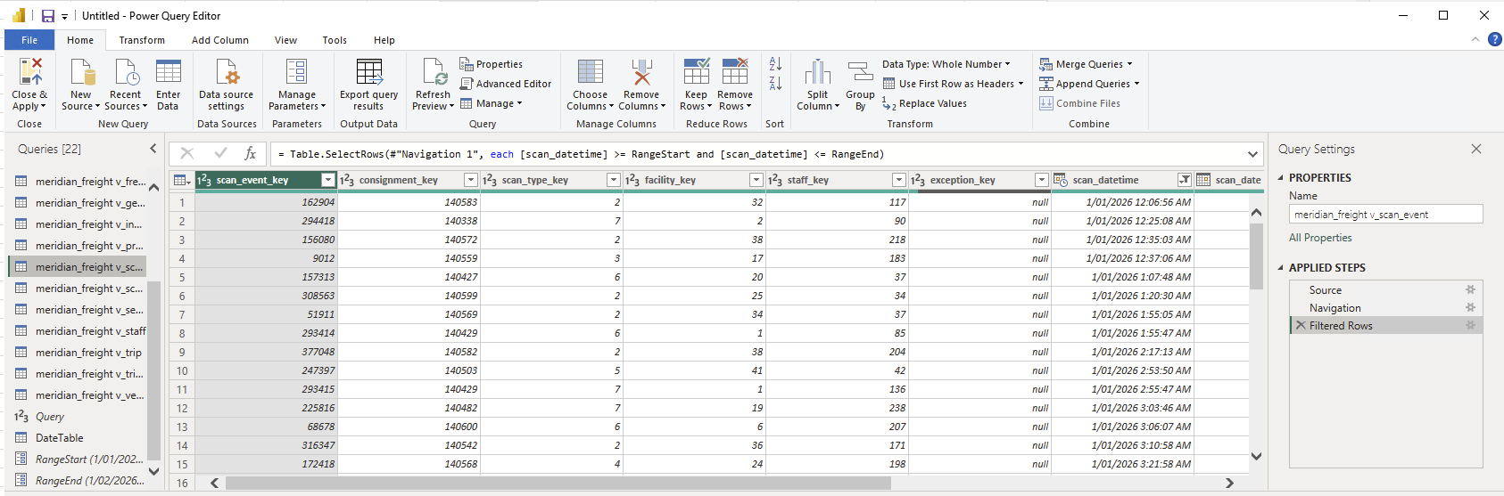

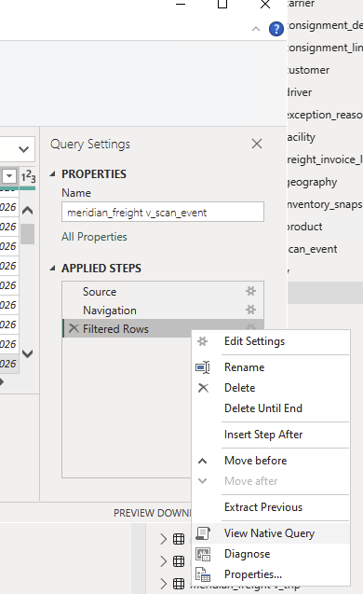

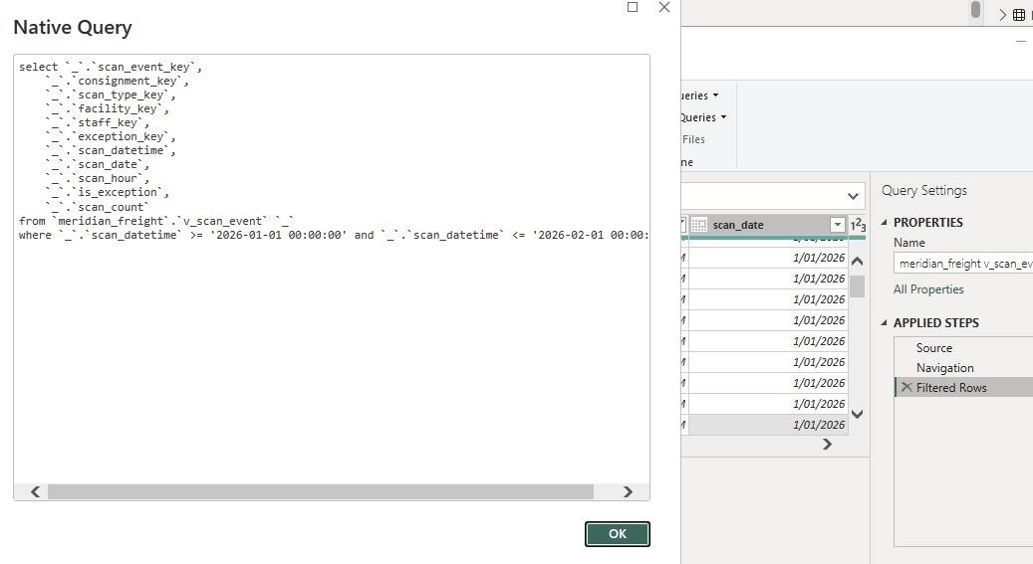

11.4 Step 3 – Defining the policy

